AP-1 AUTOPILOT
W/GPS COUPLER AND

S-2 SERVO

NAVAID DEVICES, INC.
641 North Market Street
Chattanooga, TN 37405
Phone: (423) 267-3311
FAX: ( 423 ) 756-6154
INTRODUCTION

Thank you for buying a Navaid Devices autopilot. We appreciate your business, and we will support you in whatever way we can to make sure you get years of service from our product.
We are quite confident that, after you read and follow the installation and checkout instructions contained in this manual, your autopilot will become one of your most valued flying tools. We like to think that you will soon come to regard it as one of your better investment decisions. Experienced pilots often make go or no-go decisions on a trip based on whether or not they have a working autopilot.
Should you ever change airplanes, you may want to use the autopilot in the new aircraft. This can be done, but you may need to change it from 14 to 28 volt operation, or vice versa. In this case the unit must be returned to Navaid for installation of the appropriate motor and solenoid. Otherwise you just need new mounting hardware.
If you have any unresolved problems after reading this manual, give us a call. We do not pretend to know all the answers, but we have been able to make the system work in every type of airplane in which it has been tried so far. And we can usually refer you to someone who has successfully installed the autopilot in a similar airplane.
Good luck. Give us a call if you run into a problem.
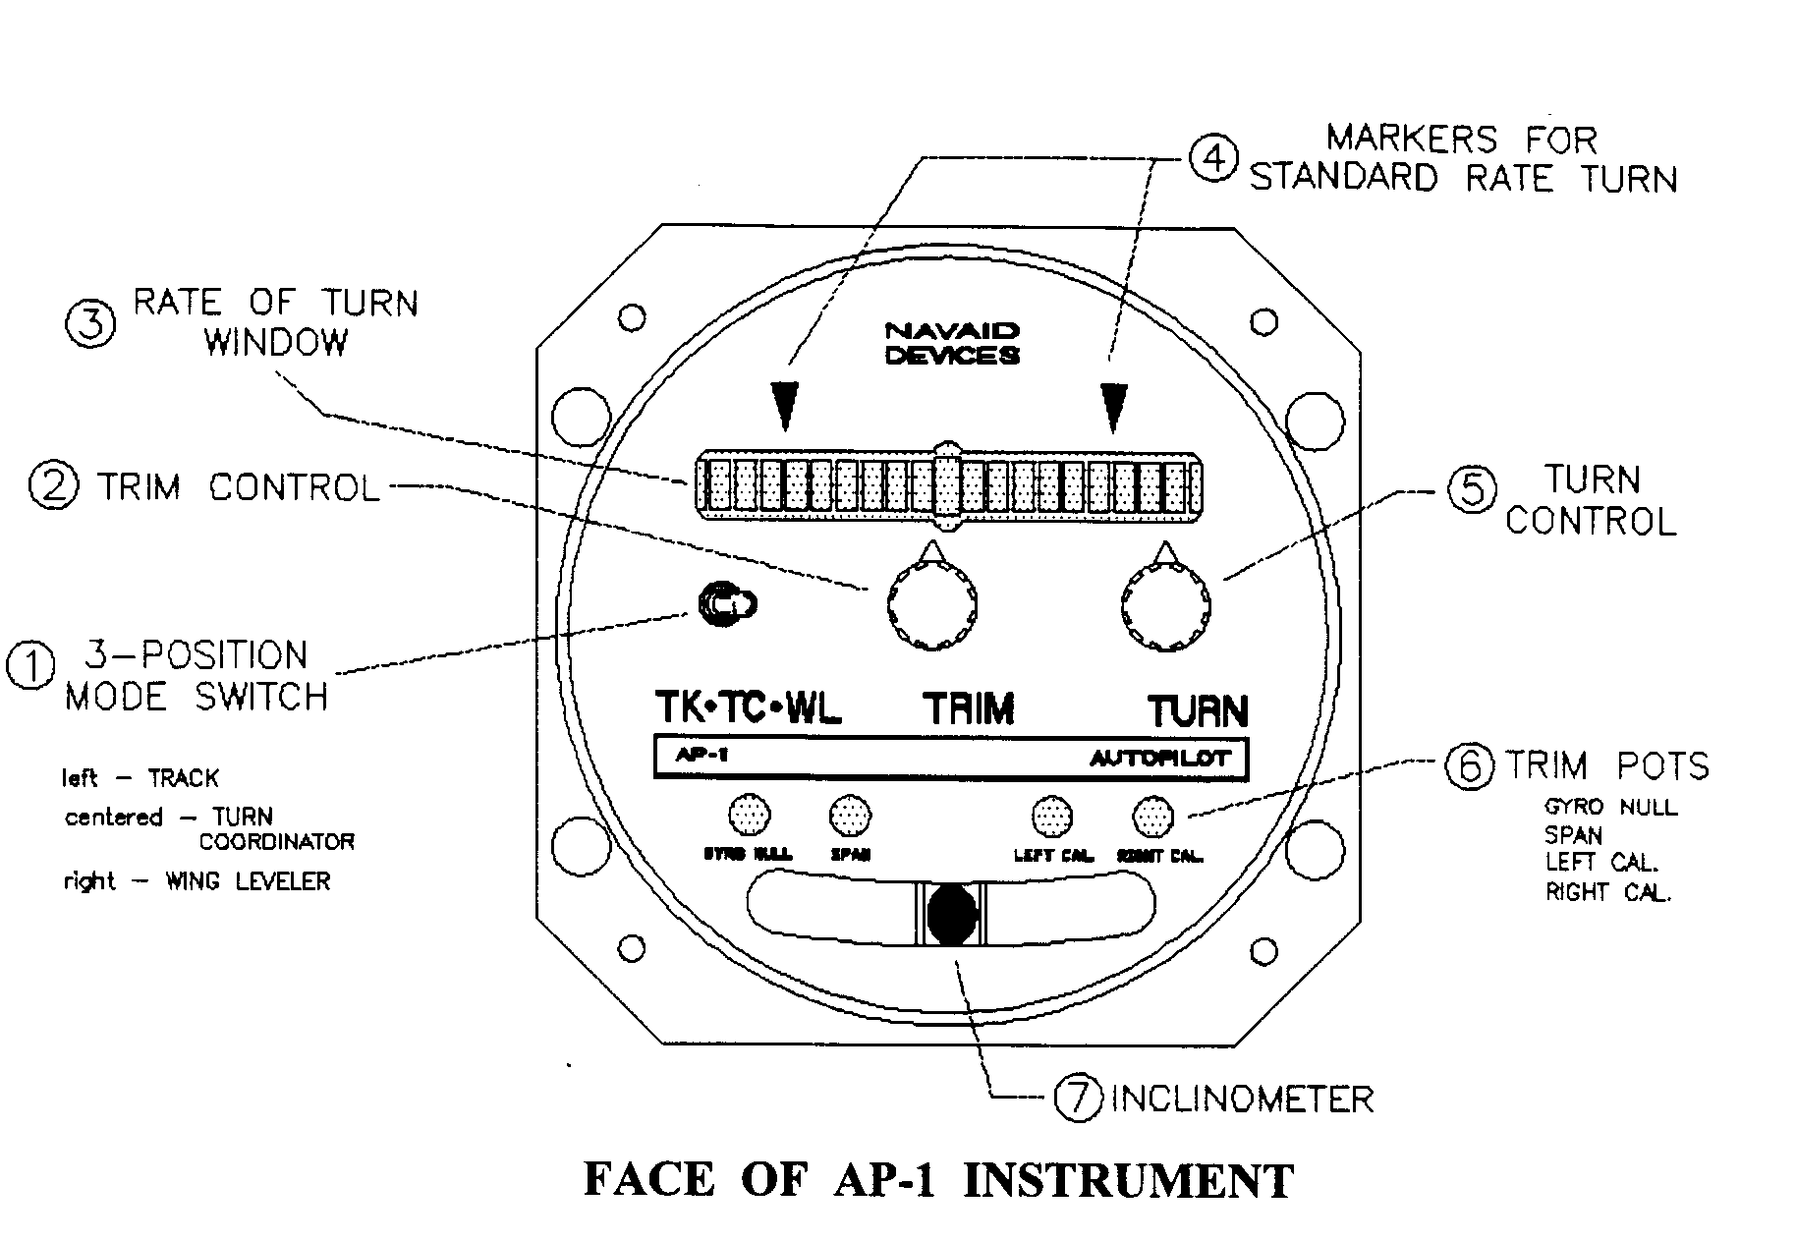
1. THREE POSITION MODE SWITCH
RIGHT: Wing Leveler Mode. Keeps wings level by reference to the built-in gyro. In this mode you can fly level, turn left, or turn right with the TURN CONTROL, item 5.
MIDDLE: Turn coordinator. This position lets you fly without the autopilot, but with the turn coordinator working.
LEFT: Track Mode. To track to or from a destination entered into a GPS, LORAN or VOR.
2. TRIM CONTROL
Trims the ailerons for straight-line flight when the TURN CONTROL is set to a zero turn rate.
3. RATE OF TURN INDICATOR
Electronically lighted bars indicate the rate of turn. The center reference bar stays lit. Additional bars lit to either side of reference bar indicate turn rate: Vi degree per second for each light.
4. MARKERS
Six lights out to the marker indicate a 3 degree per second standard-rate turn.
5. TURN CONTROL
When the airplane is in the Wing Leveler Mode, this knob turns the airplane left or right.
6. TRIM POTS
These trimpots are used to match the autopilot to your aircraft. Once these pots are adjusted (details in the owner's manual) further changes should not be necessary.
7. INCLINOMETER
Old fashioned "ball" coordinated turn or level flight indicator.
HOW TO FLY WITH THE AP-1
(an overview)
1. Start the AP-1 by whatever switch connects it to the power buss. The gyro will rev up. Have the MODE SWITCH in the center (TC) position and the TURN CONTROL pointing straight up.
2. After the gyro is up to speed (about 5 seconds), turn the MODE SWITCH to WING LEVELER. You are now flying on autopilot with the gyro keeping your wings level. With the TURN CONTROL knob you can turn right or left to bring the airplane to any desired heading. A greater turn of the knob gives a steeper turn that will be shown on the electronic bar indicator.
Point the TURN CONTROL straight up to command a zero turn rate, and adjust the TRIM knob to make the airplane fly straight and maintain a given compass heading. Just watch for needed corrections, and of course observe your altitude.
3. If you have connected GPS, LORAN, or VOR, you can track to or from a waypoint. The general rule is to fly to within 5 degrees of the VOR heading, or 2 miles of the GPS / LORAN track, to lock on. Do this by throwing the MODE SWITCH leftward to TRACK.
After you are "hooked up" to your tracking signal, you can relax a bit. Just monitor the flight, and stay ahead of the airplane.
4. TURN COORDINATOR MODE. When you wish to fly without the automatic pilot, throw the mode switch to the mid position, and fly manually. The servo is off and disengaged, but the electronic bars of the turn coordinator continue to operate.
HOW TO INSTALL THE AUTOPILOT IN YOUR AIRPLANE
(an overview)
The entire job of the autopilot is to have the power driven crank arm, which is linked to your airplane's aileron controls, push the stick left or right when you request or require aileron adjustment. That's all. Further discussions simply relate to ways to do this, and to tweaking the installation.
Begin by looking for a point where pushing or pulling a distance of 1.5 to 2.4 inches will do the job. Then find a place to mount the servo nearby to accomplish this by means of the pushrod. You will mount the servo and pushrod so that the ailerons are neutral when the servo crank arm is at mid position. That's it, aside from carefully checking that the required range of aileron movement is transited within the limits of the servo travel range.
Of course you will mount the AP-1 control unit in full view, and wire it with a circuit breaker/switch (not supplied) to the power buss.
INSTALLATION OF SERVO ACTUATOR - S2 CRANK ARM
The S-2 crank arm servo is easier to install than the capstan version and is suitable for all but the largest homebuilt aircraft with heavy aileron loading. Because most installations use the crank arm servo, information specific to the capstan servo is found in Appendix A.
The S-2 crank arm servo uses a pushrod terminated by rod end bearings to link the servo arm to the aircraft's aileron control system. We try to identify the type of rod end bearing the customer needs for his intended installation and include it with his order. If it turns out that your pushrod is not long enough (it must be trimmed to the correct length), or the size of your rod end bearing is incorrect, please contact Navaid for parts exchange.

CONFIGURING THE CRANKARM
In your installation it may be more convenient to rotate the crank arm to a new orientation that will give a neutral at +/- 90 degrees or 180 degrees from that as supplied by Navaid. The servo crank arm is secured to a flange by four machine screws that can be removed for indexing the crank arm +/- 90 degrees.
If you wish to rotate the crank arm 180 degrees, it is easier to just remove one of the stops that limit crank arm rotation, rotate the crank, and replace the stop. It will be necessary to change the indexing of the feedback pot after this, see RESETTING SERVO NULL POINT, page 8.
In most cases the servo is installed with the bottom of the servo parallel to the ground, but it operates equally well upside down or sideways
There are four holes in the crank arm that give operating radii with the combinations of force and peak-to-peak travel listed in Table 1 below:
Crank Arm Max. Travel Force
Radius (peak-to-peak) (@ 30 in-lb)
1.0 in. 1.5 in. 30 Ib.
1.2 in. 1.8 in. 25 Ib.
1.4 in. 2.1 in. 21 Ib.
1.6 in. 2.4 in. 19 Ib.
Table 1
Choose the shortest operating radius on the servo crank arm that allows full aileron movement (aileron stop to aileron stop) without driving the servo crank arm into its limits (+/- 50 degrees).
SERVO MOUNTING HARDWARE
The installation kit that Navaid offers for the Varieze, LongEZ. and Cozy is shown in Fig. 2.
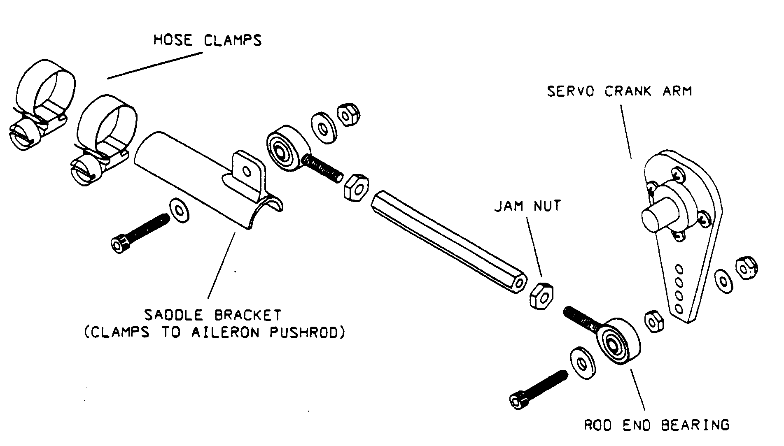
INSTALLATION KIT FOR RUTAN EZs
Fig. 2
Kits for other aircraft at least consist of a pushrod (cut to proper length by the user) and a suitably sized rod end bearing for connecting to the airplane. When we are familiar with the customer's aircraft type and know of a special requirement, we try to provide any necessary special part that might be difficult for him to make.

SELECTING A SITE FOR THE SERVO
For most aircraft, it's relatively easy to find a suitable site for locating an S-2 crank arm servo. The length of the pushrod, and to some extent the angle it makes with the driven element, are user selectable.
The rod end bearing allows some misalignment, usually about 8 degrees, between the servo pushrod and the plane of rotation of the crank arm. This limitation on angular displacement often determines the minimum pushrod length. Any side-to-side movement, such as may be caused by elevator action being mixed with the aileron movement at the stick, must not jam the rod end bearing.
A suitable hard point must be found, or built, for mounting the servo. Of course, the mounting place needs to be as accessible as possible, and there must be a means of linking to the aileron control system.
NOTE: A longer crank radius dictates a correspondingly longer radius at the drive end. The ailerons must travel from aileron stop to aileron stop within the range of movement allowed by the servo stops that limit crank arm rotation.
The mounting place must be strong and rigid-conceivably a lateral force of up to 50 pounds could be encountered. If, for example, you need to mount the servo on the skin of an airplane, it probably will be necessary to use additional bracing or a doubler to provide appropriate rigidity. You do not want the push-pull of the servo to fatigue the metal that holds it.
Usually the servo pushrod will terminate on a control stick, a bellcrank, or perhaps a lever sticking off of a torque tube. But in some cases (EZs, for example) it is more convenient to terminate on an aileron control pushrod, in which case care should be taken to keep the pushrod from being free to rotate. To do this, loosen the jam nut that secures the rod end bearing in the pushrod, rotate the pushrod and jam nut in opposite directions to remove any rotational slack, and retighten the jam nut. The reasoning for this is as follows:
The servo pushes or pulls on a saddle bracket mounted on an aileron control pushrod, the attach point being offset maybe an inch from the centerline of the control pushrod. If the two pushrods are not perfectly aligned, the control pushrod may rotate instead of moving sideways. Rotating, instead of moving, has the effect of putting play, or slack, into the linkage, and the control movements in track mode are so small that it takes very little slop in the system to make the airplane not track properly.
It will simplify installation adjustments if there is enough overhead clearance to allow removal and replacement of the servo lid with the servo remaining in place. The servo lid is secured by four screws at the side of the box. But, if it is more convenient, the lid may be secured through holes in the top of the lid. There are two pots (potentiometers) and a nut on the output shaft which should be adjusted with the lid off.
INSTALL THE CRANK ARM SERVO
Mount the servo without connecting the pushrod. See Fig. 3 on the next page and the loose sheet showing how to solder the connector pins. The power and ground conductors should be # 18 or larger. The servo signal wire carries little current and may be as small as #24 stranded. If you also wish to hook up your nav receivers at this time, further discussion starts on page 11.
WIRING DIAGRAM FOR HAND-HELD GPS AND AP-1 WITH GPS COUPLER
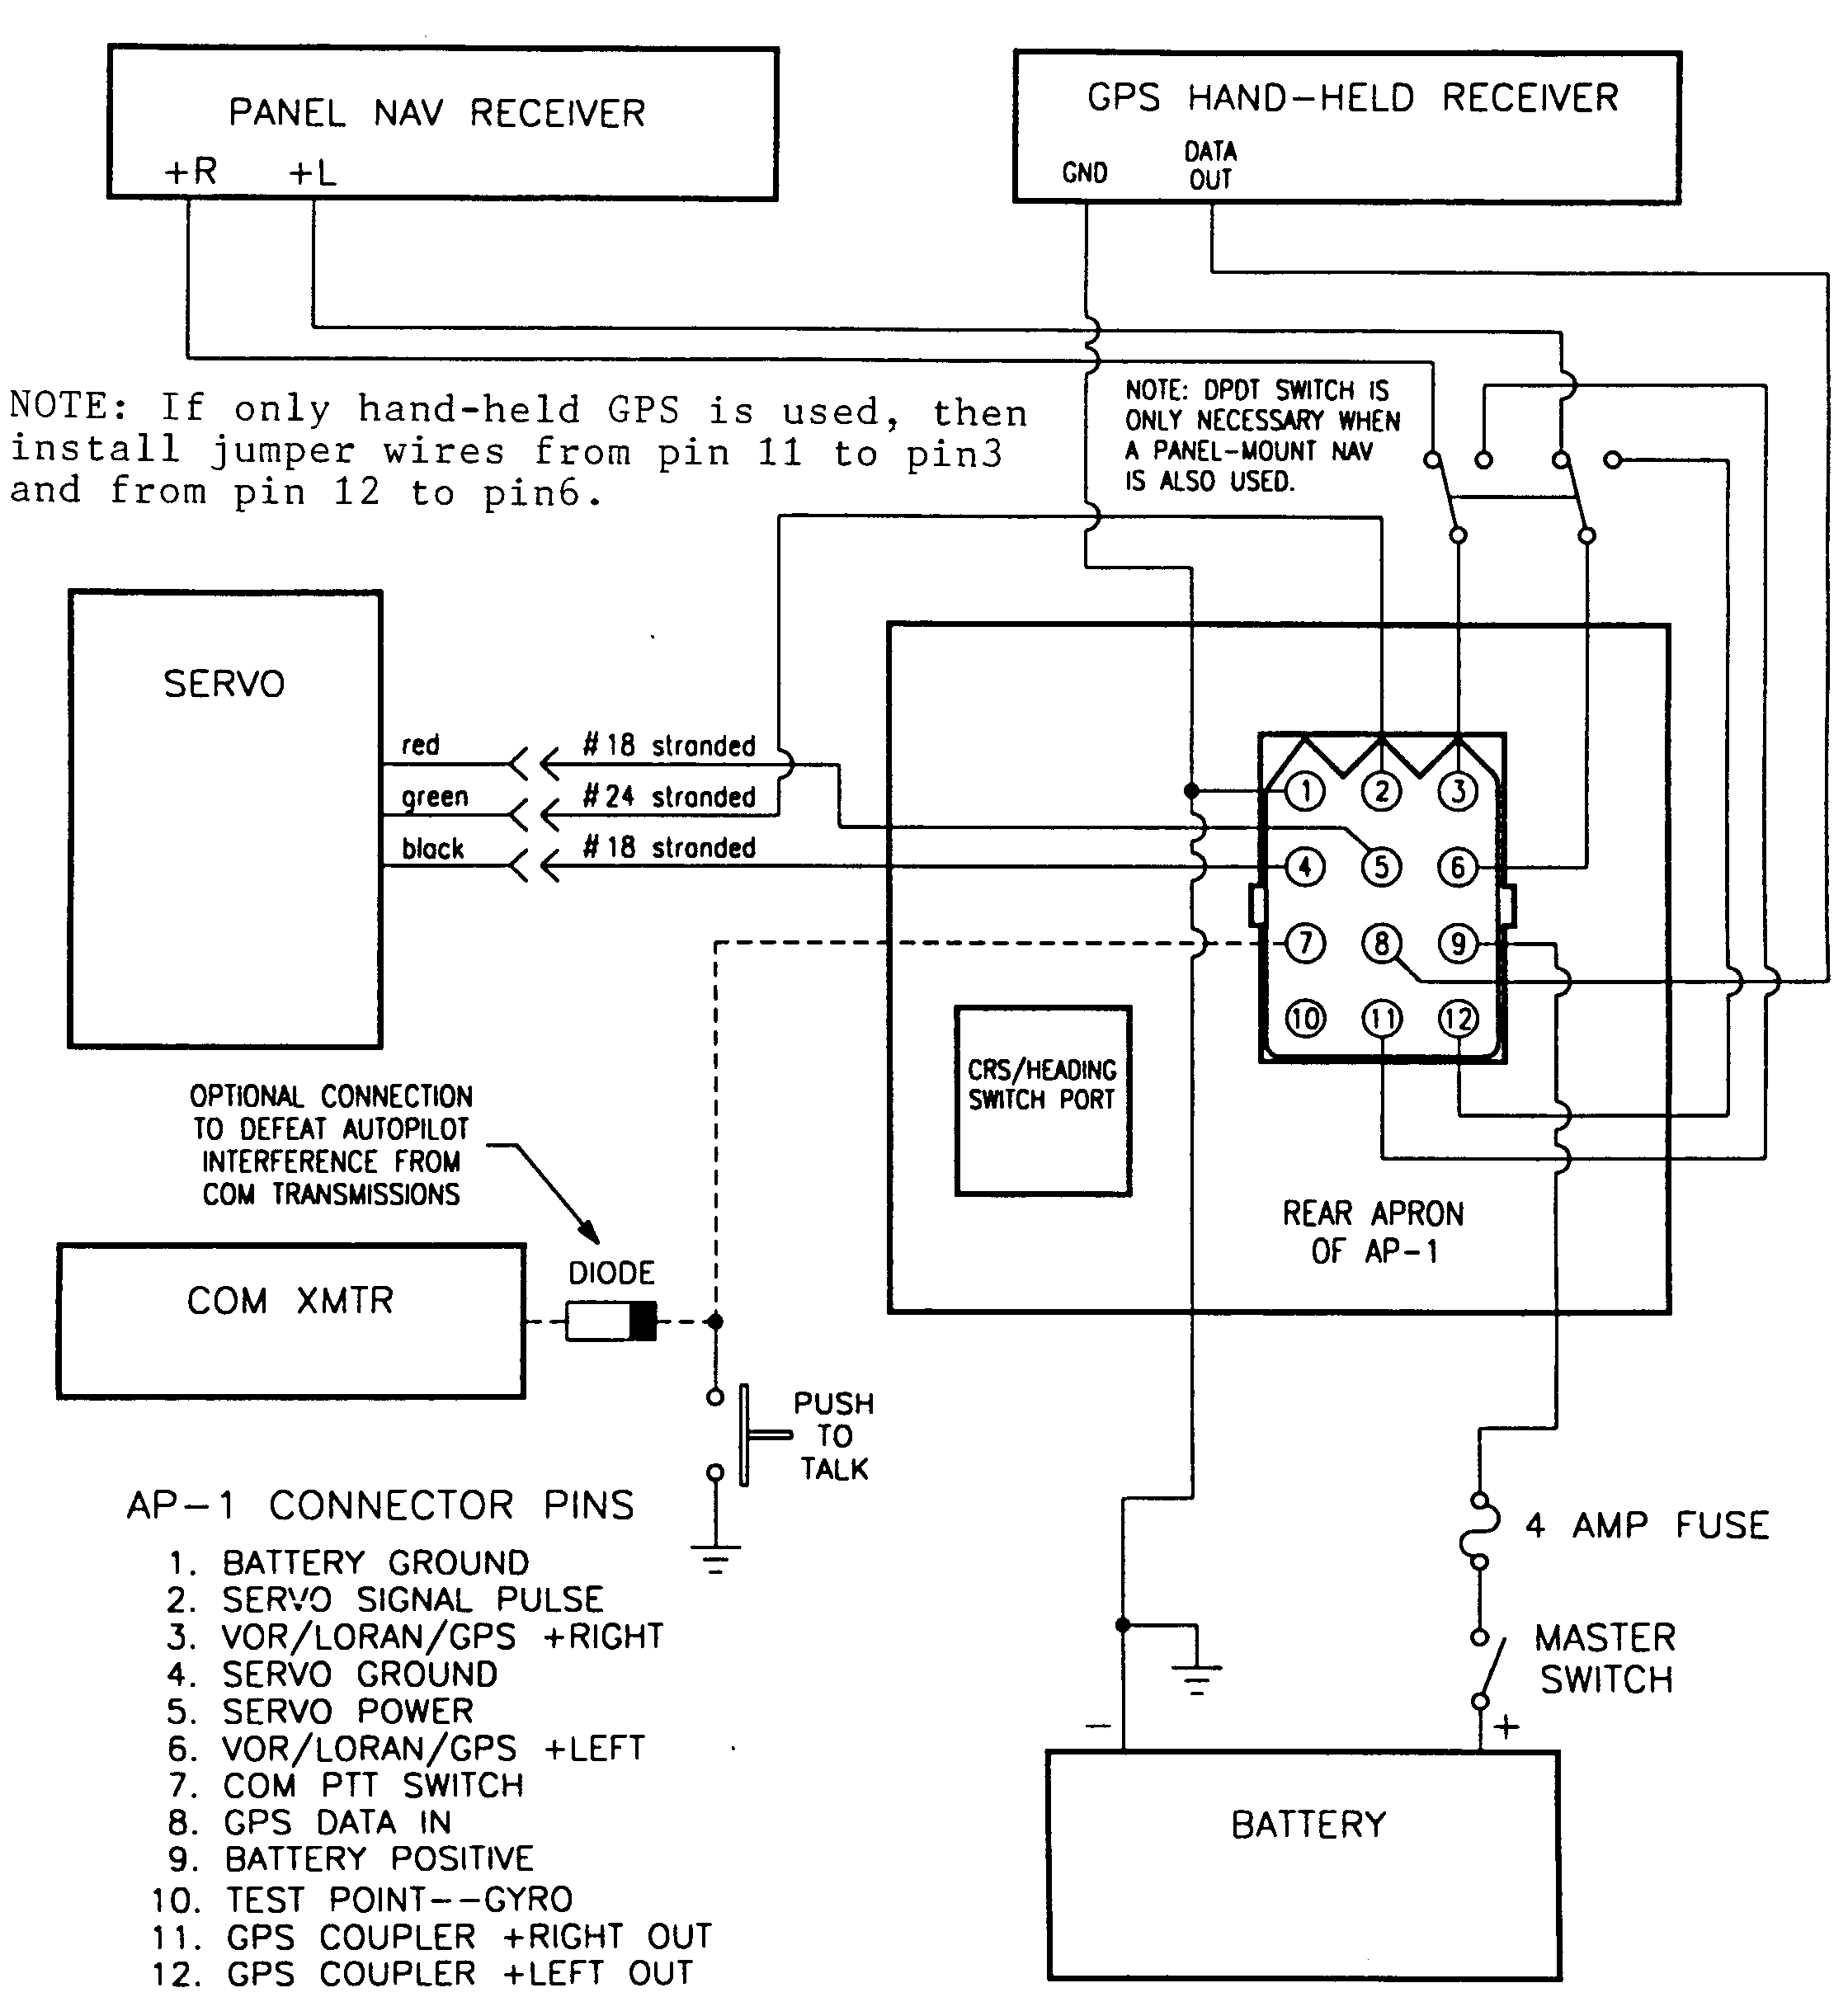
WIRING DIAGRAM
Fig. 3

CHECKOUT
Do not use just a battery charger by itself to supply the power for testing your autopilot. The voltage out of one of these has too much ripple. Connect a battery charger to the aircraft battery and leave it on whenever using the servo. Otherwise the 1 amp drain of the servo can pull the battery voltage below 12 volts and cause improper operation.
See Fig. 1 for a view of the AP-1 controls. Flip the Mode Switch on the AP-1 to the right for Wing Leveler mode and turn on the aircraft master switch. The gyro should start to wind up, and the servo should crank to a stop somewhere.
CHECK DIRECTION OF CRANK ARM ROTATION
CAUTION: The trimpots (item 5 in Fig. 1) to be adjusted in the following procedures turn quite easily. If a pot resists rotation, do not force it—it probably is already turned as far as it will go in that direction. The counterclockwise rotational limit is around 8 or 9 o'clock and the clockwise rotational limit is around 3 or 4 o'clock.
The GYRO NULL trimpot is factory set and should not need adjustment. But if you do turn it by accident, just use a voltmeter to set the voltage between pins 10 and 11 on the rear connector of the AP-1 to zero, or as close to zero as you can get it-the voltage may wander a few millivolts. Make sure that your voltmeter—digital preferred—is set on its most sensitive scale. Also, the cover of the AP-1 must be on (there is light sensitive circuitry inside the instrument) and the AP-1 must be held still for this adjustment.
Set the SPAN trimpot fully clockwise. Rotate the TURN CONTROL for a right turn, and note the direction of crank arm rotation. When the pushrod is installed, this rotation must deflect the ailerons for a right roll.
If the aileron deflection is backwards, you must reverse the direction of servo rotation. See Fig. 3 on the next page. Swap the motor wires at the motor. Swap end connections at the FEEDBACK pot-these wires are white with red tracer and white with black tracer. If necessary, reset servo null point.
RESETTING SERVO NULL POINT
When you turn the servo on after reversing the servo direction, or after changing the orientation of the crank arm by 180 degrees, the servo may drive into its mechanical limit and just keep grinding, slipping the clutch. This happens because the null point to which the servo is trying to go has been moved to a position outside the range of servo travel.
To fix this, do the following:
1) There is a nylon gear on the back end of the output shaft that engages another gear on the feedback pot shaft. Loosen the set screw that secures the gear on the output shaft, then slide it back so that it no longer engages its mating gear.
2) There is a U shaped gear engage rocker arm that the solenoid normally pulls up to engage the gear train. Hold this down to keep to keep the gear train from engaging (it does not hurt anything to let the crank arm hit the stop and grind, but the noise is annoying), then turn on the autopilot. The motor will run continually.
3) Rotate the feedback pot-the motor will reverse direction at two points during a 360 degree rotation of the pot shaft. At one of the points, the motor abruptly switches from full speed one way to full speed the other way. Find the other point, which is not really a point but a very narrow range within which the motor can be made to a stop, or run relatively slowly in opposite directions on either side of the stop. Turn the autopilot off anywhere within this range.
4) Without rotating the feedback pot shaft any more than you help, re-index the gear on the shaft so that the set screw is pointing straight up within, say, +/- 15 degrees. 5) Point the set screw on the output shaft gear about straight up, engage the two gears, point the crank arm where you want it, and tighten the set screw. Do not to use too much torque tightening the set screw. You want to hold the gear firmly on the shaft, but below, under SETTING SERVO NEUTRAL, you will need to force the gear to rotate with respect to the shaft.
6) Turn on the autopilot. The servo should crank to a stop without moving very much.
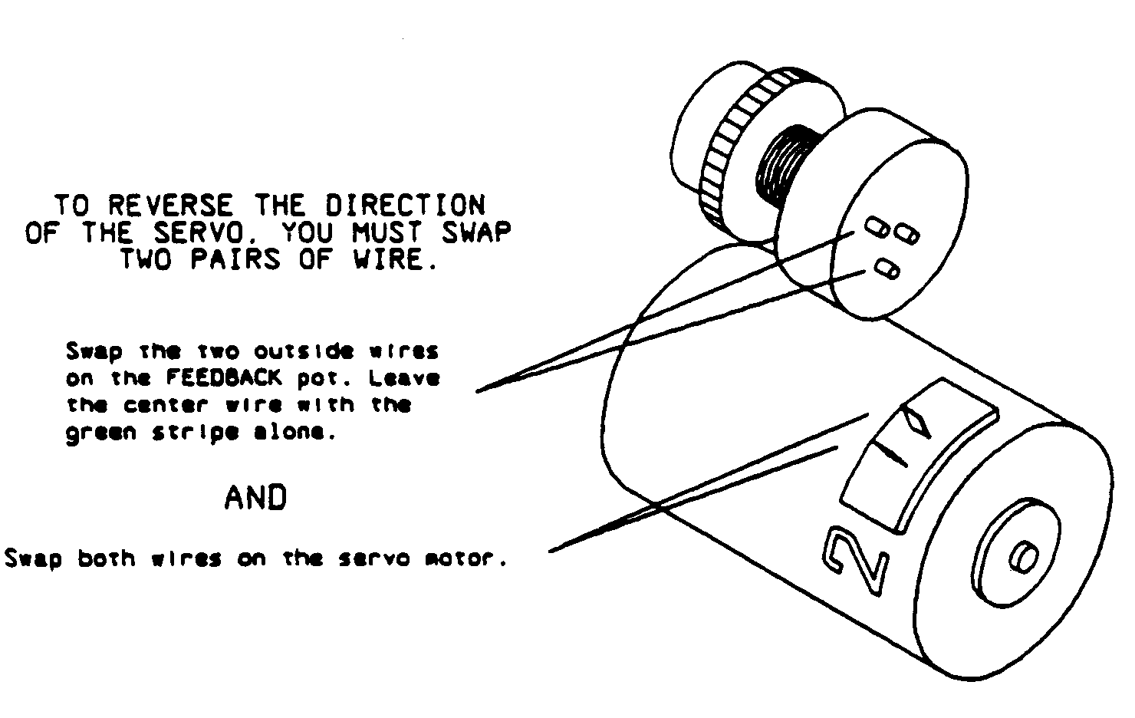
SERVO MOTOR AND FEEDBACK POT TERMINALS
Fig. 4
CHECK INDEXING OF TURN AND TRIM CONTROLS
Check the TURN and TRIM CONTROLS for proper orientation of the indicator. The limits of rotation of each control should stop the indicator at points equally displaced from 6 o'clock, in which case the indicator will point straight up at the center of rotation.
The TURN CONTROL has a dead zone, which is anywhere in the center 10 degrees of shaft rotation. The dead zone is there so that the control does not have to be exactly centered to command a zero turn rate. Point the indicator straight up to put it tin the dead zone.
Center the TRIM CONTROL and TRIM RANGE trimpot. Now the AP-1 should think the airplane is flying straight and level, and the servo is locked into the position that it would hold for neutral aileron. The crank arm will be positioned properly for level flight in the following segment
INSTALL THE SERVO PUSHROD
Cut the pushrod to the proper length so that, when the servo is at neutral, the ailerons are also neutral. Do not worry about being exactly correct-the ailerons can easily be jinked to a new neutral.
Choose the longest possible crank arm radius that accommodates a pushrod range of movement equal to or exceeding that required for full aileron travel. Be sure that the rod end bearings never jam due to misalignment as the pushrod angle is varied by different combinations of aileron and elevator input. Put the stick in all four comers.
SETTING SERVO NEUTRAL
Find the FEEDBACK pot: it is mounted on the servo frame above the motor (see Fig. 4), and it has a small gear mounted on its shaft. If you twist that gear, the servo will crank until you let go, indexing the crank arm to a new position. You can use this feature to jink back and forth until you get the neutral located exactly where you want it.
NOTE: if the small feedback gear is very difficult to turn, loosen the set screw in the larger gear somewhat. The output shaft must rotate with respect to its feedback gear when the crank arm is indexing to a new position. IMPORTANT: After this adjustment, check the setscrew again to make sure that it is not too loose.
SETTING SERVO RANGE
Another servo adjustment is a small trimpot located on the printed circuit board. This is the servo RANGE trimpot, and turning it clockwise increases the range over which the servo operates.
Set the SPAN trimpot in the AP-1 fully clockwise, then rotate the TURN CONTROL from stop to stop and note the maximum obtainable aileron deflection. Adjust the servo RANGE trimpot as necessary to obtain about 50 of full aileron deflection at the limits of TURN CONTROL rotation.
SETTING SERVO OVERRIDE FORCF.
The servo TORQUE CONTROL nut (the locknut inside the servo on the output shaft) sets the override force, which is the force you feel at the stick when the servo clutch begins to slip.
Set the TURN CONTROL to neutral and then push the stick hard enough to override the servo. Set the override force to a value that seems strong enough to give fairly good roll authority, but not so strong as to be difficult to override. In subsequent flight tests, work toward setting the servo slip clutch to the minimum torque necessary to give enough roll control to handle a reasonable amount of turbulence.
If you tighten the clutch enough to exceed the 30 in-lbs maximum torque rating, you may hear a loud clacking sound in the servo and the servo may disengage. This clacking happens when the force pushing the gears apart exceed the solenoid's ability to hold the gear train engaged. This is a redundant safety feature-just back off on the control nut a little and recycle the power switch to re-engage the servo.

CONNECTIONS TO NAV RECEIVERS
Fig. 3 shows the autopilot interconnection wiring diagram. As stated earlier, the power and ground conductors should be #18 or larger. The servo signal wire and push-to talk switch wiring may be as fine as #24, or whatever heavier wire is convenient.
Use the supplied braided shield twin lead for the LORAN signal; do not use foil shield. If you need extra, call Navaid Devices. Ground the shield on only one end (Fig. 3 shows grounding at the AP-1 end). This shielded wiring is necessary only if you are connecting to a LORAN—it prevents the gyro motor from lowering the signal to noise ratio.
When soldering the shield, be careful not to let the shield overheat the plastic and short to the conductor. If you separate enough braid so that it can be held by a pair of needle nose pliers while soldering, the heat from the braid will be soaked up by the pliers without damaging the insulation.
The diode installed in series with the push-to-talk line, together with the wire connected from the PTT switch to pin 7, are used to kill the signal to the servo while the PTT switch is depressed. This prevents the servo from jumping around due to the presence of high level RFI (radio frequency interference) on the power lines. The servo stays engaged during the voice transmission, but it does not move until normal operation is restored by releasing the mike button.
We do not know all we would like to know about RFI, but we do know that the signal kill wiring discussed in the previous paragraph is unnecessary in some cases. If you are using shielded wiring in a metal airplane, RFI probably will not be a problem, and it may not be a problem if you have shielded wiring in a composite airplane. But a composite airplane with unshielded wiring usually needs the signal kill circuitry.

AUTOPILOT OUTPUT PINS ON NAV RECEIVERS
Your navigation receiver should have two output signal terminals to be used for driving an autopilot or a CDI. Usually they are labeled '+ Left' and '+ Right', and they are to be connected to the corresponding AP-1 terminals. If the labeling is ambiguous, as it is on at least one fairly popular radio, just connect both wires without worrying about polarity and check it out in flight test.
Many of the hand-held GPS or LORAN receivers, and a few of the panel mounted units, have digital autopilot outputs that are not compatible with the analog (varying dc voltage) signal required by the Navaid autopilot. If you have not yet bought your navigation equipment, please check with the manufacturer—your receiver (GPS, LORAN, or VOR) should be able to drive an external CDI, and this same signal is used to drive the autopilot. If you are already driving an external CDI, just put the autopilot in parallel at the same terminals.

MOMENTARY DISCONNECT SWITCH
In addition to the wiring shown in Fig. 3, you may wish to add a momentary pushbutton switch in series with the servo power line. This switch would be located on or quite near the stick, and it would disconnect the servo as long as the button is depressed. A lighted, round switch that can mount in a 0.43 inch diameter hole is available (at the time of this writing) from Mouser Electronics, phone (800) 346-6873. Use the two switch terminals (of three) that are normally closed to interrupt the servo power wire.

Cap Color | Part No. | Price
Red | 10PL031 | $11.08
Yellow | 10PL033 | $11.08
Green | 10PL036 | $11.08
Momentary Pushbutton Switch Options

Table 2

CIRCUIT BREAKER/SWITCH
Instead of a switch and a separate in line fuse, you might want to consider a circuit breaker/switch. Use a fast acting (NOT instantaneous) 3 amp magnetic circuit breaker/switch (2 amp for 28V systems).
Carlingswitch (call (203) 793-9281 for nearest distributor) makes a nice looking, gray colored, lighted, 3 amp rocker switch that snaps into a rectangular cutout. The part number is MF1-B-32-430-1-JC2-7-A. Each section of this long part number indicates a different option—you might want to get a catalog and change, for example, just the color of the light (this one has a green lens).
Or you may prefer the convenience of round hole mounting a similar sized black lever switch available from the Airpax division ofPhillips Technologies (call (410) 228-4600 for nearest distributor, part number Tl 1-1-3.00A-OI-10A-V).
PREFLIGHT CHECK
Set the TURN CONTROL to midrange and make sure it is in the center dead zone. To do this, set the AP-1 to WL mode (flip Mode Switch right) and slowly rotate the TURN CONTROL from stop to stop at a constant speed. You will hear the servo pause as the knob passes through the dead zone. If you do the same thing while you are flying, the wings will momentarily stop rolling as the knob goes through the dead zone.
Set the TRIM and TURN CONTROLS to midrange. Set TRIM RANGE, LEFT CAL, and RIGHT CAL trimpots to midrange. Leave the GYRO NULL trimpot alone. Set the SPAN trimpot fully clockwise (Note: the servo range goes to zero when the SPAN trimpot is fully counter-clockwise). Put a small screwdriver in your pocket for adjusting trimpots in flight.
Put the autopilot in Wing Leveler mode (Mode Switch to right) while taxiing. Make a right turn, and you should feel the stick move to the left, and vice versa. A right should give left aileron. The servo must always work against whatever the airplane is trying to do on its own.
BE DAMN SURE YOU CAN OVERRIDE THE SERVO ANYTIME YOU WANT!
Test the override by pushing the stick both left and right.
DISENGAGE THE AUTOPILOT BEFORE TAKEOFF.
The servo is disengaged only when the Mode Switch is in its center position. The turn coordinator always operates, no matter what position the Mode Switch is in.
TEST FLIGHT AND CALIBRATION
Take off, get some altitude, and set up a level cruise. If you have cockpit adjustable trim, set it as necessary to achieve straight line flight.
Flip the Mode Switch rightward to the Wing Leveler position. The autopilot should take control. The airplane probably will start a gentle turn indicating an out-of-trim condition. If the system gain is set too high, the stick may feel jittery and the airplane may weave back and forth.

SETTING SYSTEM GAIN
The autopilot should fly the airplane in a manner more or less similar to that of human pilots. If the stick action feels too jittery for the weather conditions, or if the airplane is continually hunting (oscillating) back and forth like a snake trying to follow a straight line, the system gain is probably set too high for your aircraft.
Remembering that the trimpots should not be forced beyond their 9 o'clock and 3 o'clock stops, you lower system gain by turning the SPAN trimpot counterclockwise. Decrease the gain (turn SPAN trimpot counterclockwise) until the stick calms down, then increase it to the point where the stick becomes jittery again. With your airplane operating at its usual cruise speed, set the gain as high as possible without oscillation or jittery stick movement.
If the SPAN trimpot ends up being set below 75 of maximum (full clockwise), the servo RANGE trimpot is set too high and tracking performance may be degraded. The following procedure increases servo resolution without changing system gain. Land the airplane and measure (better write it down) the full range of aileron movement obtainable using the TURN CONTROL with the autopilot in Wing Leveler mode.
Set the SPAN to about 90 of full clockwise rotation.
Adjust the RANGE trimpot on the servo printed circuit board to restore that same range of aileron deflection.

TRIMMING THE AUTOPILOT
Do not touch the TRIM or TURN CONTROL now (they should already be at midrange). Adjust the TRIM RANGE trimpot to make the aircraft fly straight. Note that you do not adjust the airplane for wings level—sometimes a rudder out of trim makes it necessary to fly with one wing a little low to achieve straight line flight. If you are flying in smooth air, it should be possible to adjust the TRIM RANGE trimpot so that the airplane will stay lined up on a distant target.
If the TRIM RANGE trimpot does not have sufficient range, reset it to midrange. Then use the TURN CONTROL to make the airplane fly straight. Leave everything as is, turn the autopilot off, and land the airplane.
When the airplane is on the ground and the Wing Leveler is engaged again, the ailerons will go to the correct level flight position. Mark this position. Now put the TURN CONTROL back into the dead zone, which will move the ailerons away from neutral. Then jink the servo FEEDBACK pot or adjust the mechanical linkage so that the aileron is returned to the marked position.

TRIMMING FOR TRACK MODE
The autopilot should be set for proper aileron trim in WING LEVELER mode before switching to TRACK. This is not a one time adjustment-you will probably have to check the aileron trim every time you use the autopilot. Trim can change as a function of power setting, fuel load imbalance, or trim tab adjustments. Aileron trim error shows up as a tracking offset.
A common mistake is to leave in a TURN CONTROL input (turn control not in dead one) while trimming the aircraft in Wing Leveler mode. This input drops out when you switch to Track, which will introduce a tracking error if the TURN control input is anything other than zero before switching. Therefore, always make sure that the TURN CONTROL is in the dead zone while trimming.
With the TURN CONTROL in the dead (zero input) zone, adjust the TRIM control or TRIM RANGE trimpot as necessary for straight line flight. If you are uncertain that you are really in the dead zone, use the TURN CONTROL to roll the airplane back and forth. Rotate the knob slowly at a constant rate, and you can detect a pause in the roll as the knob goes through the dead zone at the center of rotation.

TRACK MODE
When you are first learning to use the autopilot to track a VOR, be sure you are within ten degrees of the correct heading and no more than ten degrees off course, i.e., just barely carrying full deflection of the CDI needle, before engaging the Track mode. In the case of a LORAN, be sure you are within 10 degrees of the correct heading and no more than 5 miles off course.
If you are using a VOR for making the following adjustments, try to stay within 1.5 to 15 miles of the VOR to be sure that the airplane responds to the adjustments within a reasonable length of time. After each adjustment, the aircraft must fly to a new bearing from the VOR before the CDI needle can stabilize.
Head toward a VOR and flip the Mode Switch rightward to Wing Leveler. Zero the CDI needle and, after a delay of about half a minute, flip the Mode Switch to the far left to change to TRACK mode. The airplane should track in over a VOR.
The purpose in the delay in switching to Track mode is to allow the charge on some capacitors in the AP-1 to stabilize. If the switch is made as soon as the needle is centered, the machine will "remember" that the needle was off, "think" that it must correct, and bank the airplane off course. If the airplane is improperly trimmed when Track mode is initiated, the CDI needle will shift away from zero deflection as the autopilot flies the aircraft as necessary to establish a stable off-course condition, a condition that generates an error signal that cancels the trim error. If you are tracking a GPS or LORAN, the aircraft settles on a course parallel to the desired course. If you are tracking a VOR, the CDI needle settles down to a different radial from that selected at the OBS and still flies over the VOR station.
The autopilot always makes the airplane follow the needle. If the CDI needle wanders around, the airplane will too. This is a VOR problem that usually occurs at low altitude over hilly terrain. If the cruising altitude is 4,000 or more feet AGL, the autopilot should track the VOR without much S-tuming, or scalloping, back and forth across the track.
The autopilot works best tracking a GPS or LORAN because of the higher quality signal. The error signal for a given distance off course stays constant in a GPS or LORAN, but a VOR signal may scallop, and signal sensitivity varies over a wide range as a function of the distance from the station.

TRIM WHILE TRACKING
The necessity for putting the TURN CONTROL in the dead zone has been discussed in TRIMMING FOR TRACK MODE on the previous page. However the "dead zone" does not necessarily command a perfect zero turn rate — but it is close. Therefore do not be surprised if the airplane drifts off a little, probably less than a mile, after following the foregoing procedure and switching to TRACK mode. This residual error, or any error that later occurs as a result of a change of airspeed or uneven fuel loading in the wings, can be corrected by turning the TRIM trimpot toward the error, i.e., turning the trimpot clockwise to correct for a CDI needle that has shifted to the right.
Sometimes you may want to track with a parallel offset from a given line. If you are tracking with GPS or LORAN that does not have this feature built in, just trim in the direction of the desired offset.
USER SELECTABLE GPS / LORAN SIGNAL GAIN
The standard error signal voltage for driving a CDI, which is also used for the autopilot, is 150 mV at 5 miles off course (cross track error) for a GPS or LORAN. Some receivers also have user selectable tracking gain that can be set to give a 150 mV error signal at 1.25 miles off course, and it may be called APPROACH MODE instead of CRUISE. Another way of saying the same thing is that it may be possible to set your receiver tracking sensitivity to 1/4 mile per dot instead of 1 mile per dot. If you have this feature, try it—most customers prefer the increased tracking accuracy.
ADJUSTING THE SERVO SLIP CLUTCH - SAFETY VS. RESPONSE
The FAA requires autopilots for production aircraft to be set up so that a hard-over failure will not cause the airplane to bank more than 60 degrees in the first 3 seconds after recognition of failure. Since it takes about a half second to recognize a failure, the time period might as well be 3.5 seconds.
For certified installations, the servo slip clutch is specifically set to meet this specification for each aircraft model. A homebuilder, who is under no such obligation, may elect not to perform the following test. Or he may perform the test and then deliberately increase the torque setting to enhance performance under turbulent conditions. But he should at least understand that there is such a thing as too much autopilot control, and that a fast response to a hard-over failure can be dangerous. If you prefer a fast response, then you should set conditions, such as minimum AGL altitude or formation flying, under which the autopilot will not be engaged.
The worst case roll condition occurs at minimum speed and aft C.G. This could be a slow airspeed if you are going to track the localizer. But we hope you just use the minimum cruise speed—the autopilot is not required to work over as large an envelope, and you can more gracefully afford a hard-over failure at cruise altitude and speed than at that typically encountered while flying the localizer.
Check the maximum roll rate with the aircraft at aft C.G. and minimum speed. Disengage the autopilot, then set the TURN CONTROL to full left mm. Hold the same airspeed as you bank 60 degrees to the right, engage the servo, and measure the time it takes for the aircraft to get to level. If the aircraft passes through level in less than 3.5 seconds, that is too fast—the servo Torque Control nut on the output shaft needs to be loosened so that the wind load on the aileron causes the clutch to slip sooner.
Before making a change to the servo, check for an adequate minimum roll rate with the aircraft at maximum cruise and forward C.G. Rotate the TURN CONTROL back and forth to see whether the aileron has adequate control. If the control is too weak, the servo TORQUE CONTROL NUT needs to be tightened.
Obviously, putting in a fix at low speed can adversely affect high-speed response, and vice versa. It may be necessary to accept a compromise.

CALIBRATING THE DISPLAY
For your information, the RIGHT and LEFT CAL trimpots affect nothing but the number of bars lit for a given rate of turn. Also, the direction is opposite of what you probably would expect: clockwise rotation of these two trimpots causes a decrease in the number of bars lit for a given rate of turn.
Disengage the autopilot and make a 360 degree standard turn to the right. Keep six bars lit out to the white triangle and time the turn. If it takes less than 2 minutes to complete the turn, set the RIGHT CAL trimpot halfway between wherever it is and fully clockwise; conversely, set it half way to fully counterclockwise if the timed turn takes longer than 2 minutes.
Make another timed turn, and correct as before but with only half as much correction, i.e., about 30 degrees of trimpot rotation. If that is not close enough, repeat the process again using half the previous correction. Three or four successive approximations for RIGHT CAL ought to get the time fairly close to the desired 2 minutes for a right turn. Repeat the procedure on standard left turns, this time adjusting the LEFT CAL trimpot.
The accuracy with which one can fly a timed turn is limited by the resolution of the display, which in this case is plus or minus 1/4 degree per second, as well as pilot technique and turbulence. The above procedure calibrates the readout so that a six bar rum gives a turn rate fairly close to 3 degrees per second, and the pilot is a component in the feedback loop, so this calibration method is probably as good as any.

MEASURING THE MAXIMUM TURN RATE
The maximum turn rate that can be commanded with the TURN CONTROL cannot be adjusted, but it is repeatable and can easily be measured. The measured value ought to turn out to be a little less than 3 degrees per second.
Measure the time required for a 360 degree autopilot turn with the TURN CONTROL fully clockwise. Divide the time, in seconds, by 360. The answer is the measured turn rate. You may want to placard the instrument panel with the required number of seconds for a 180 degree turn each way.
THIS IS A VFR AUTOPILOT
Please remember that th& Navaid autopilot is not recommended for use in IFR conditions. The components used in the kit are probably as reliable as any, but the system has not been through the test regime that would be required of a type accepted piece of equipment. Also, the installation was not done by a professional. These factors necessarily result in a system of unproven reliability, so please do not bet your life that this machine can carry you through a cloud.
COMMON PROBLEMS AND QUESTIONS
(1) If the autopilot is engaged while the airplane is on the ground, the stick shakes continually. Why?
The servo has a very narrow dead zone in which the crank arm should stop. The problem is that once a system with a fair amount of mass starts to move, it does not want to stop. After the servo motor stops driving, system momentum carries the output arm through the dead zone. Then the servo motor reverses, again overshooting the dead zone, and the reversing process goes on repeating itself indefinitely.
The pair of interconnected sticks acts like a pendulum, or flywheel, that wants to keep the system moving. The trick is to leave the dead zone as narrow as possible and still get the servo to stop there.
Try placing a little side load on the stick with your finger while flying at cruise speed. If this makes the stick stop oscillating, you can probably cure the problem by somehow effecting a small trim change that would add an equivalent stick force. The explanation of this is that, when the stick is moving against the finger force, it stops sooner than it otherwise would and thereby stays in the dead zone.
(2) Why is there a bubble in the inclinometer?
The volume of the liquid and the internal volume of the glass tube changes with temperature. The incompressible liquid would crack the glass if the air bubble were not there to absorb the effect of these changes. The size of that bubble changes by a factor of at least three over the expected temperature range.
You do not see the bubble in most regular turn coordinators. They have enough room inside the instrument case to allow a stack, or vertical tube at one end of the inclinometer, in which the bubble resides out of sight.
(3) The autopilot works well in Wing Leveler mode, but not in Track mode. Why?
The error signal developed as a result of the airplane being a little off course is quite subtle compared to the relatively large signal caused by a banking airplane. Sometimes the autopilot works in WING LEVELER even though there may be problems significant enough to keep it from doing a proper job in TRACK mode.
There are a number of different ailments that can cause the above symptom. The following is suggested as a systematic way of trouble-shooting:
A) Verify that you really have a problem.
Sometimes first time users think that the airplane is not tracking when everything is working normally. Do not give up if the airplane does not immediately hold track. Read the flight test procedure again, paying particular attention to that portion dealing with trimming the autopilot. If the trim is not set properly, the aircraft will not track properly.
Even though you are quite careful, sometimes a trim error large enough to affect tracking exits at the time the autopilot is switched into TRACK MODE. Make sure you followed the correct trim procedure, then let the airplane drifts out as much as 5 miles. If the airplane turns to run a course parallel to that called for by the GPS or LORAN, or flies a different radial toward the VOR, just adjust the trim knob. Trim toward the needle deflection.
B) Verify that a tracking signal is present at the input to the AP-1.
The receiver could be broken, or the signal wiring could be faulty (open, shorted to ground, or reversed).
If you can switch to another receiver, try that. Chances are that two receivers are not both broken at the same time.
If you are trying to track a GPS, a quick check is to switch to the VOR and roll the OBS back and forth. If the wings follow the CDI needle, you have a signal and should be able to track the VOR. If your wings roll against the needle, your signal wires to the VOR (but not necessarily the GPS) are reversed.
If you use just one receiver, put a voltmeter across the tracking signal leads at the AP-1 connector. You should be able to measure 150 millivolts (0.15 volts) between the two wires (the voltage from either wire to ground is irrelevant) when the CDI shows 5 dots deviation. The polarity of this voltage should reverse if the direction of deviation is reversed.
If your GPS or LORAN allows you to program in a course offset, you can do the signal test on the ground. Program in a course offset to the right, followed by an offset to the left, and see if the ailerons move in the proper direction. You can accomplish the same thing if you can program in a point of origin for a trip other than your present (ground) position, i.e., plug in an origination point 5 miles away.
Also you can check out a VOR signal on the ground, assuming you can receive a VOR signal. Just move the OBS to sweep the needle toward, say, the "FLY RIGHT" side of the dial and watch for right roll direction of aileron deflection.
If there is no signal at the AP-1, check to see if the shield, which is grounded at the AP-1, could be shorted to either conductor. You may not be able to see it if this is the case, but an ohmmeter will read zero resistance between the shorted signal wire and the shield. Then check continuity to the receiver on both wires.
C) Check for problems in the aileron control system.
LongEZ, Varieze, and Cozy airplanes give the most trouble as a result of friction. They all have a good bit of play in the linkage, which is not so harmful if the relatively high pressure air on the bottom surface of the ailerons is sufficient to blow the ailerons up and thereby take the slack out of the system. If you are still building, please take all possible precautions to insure a friction free system.
When the airplane is tracking a GPS or LORAN in the standard cruise (1 mile per dot) mode, it has to move out about 0.35 miles from the track centerline to transit the dead zone. At about a half mile from centerline an unloaded servo will move the max. radius crank arm hole only about 0.01 inch, which means that this movement will be lost if there is any slack in the system. A maximum track error signal (150mV) at the AP-1 input probably moves the max. radius crank arm hole only about 0.17 inch (varies-depends on adjustments).
The "feel" of the ailerons is largely determined by the designer, but some airplanes of a given species have unusually "heavy" ailerons. One way this can happen (there may be others—I am not competent in this area) is by the builder increasing the thickness of the control surface trailing edge. He will end up with a stiffer system than was intended.
The problem with stiff ailerons is that the servo must exert extra force to move the ailerons. This means that the airplane has to drift further from the desired coarse to pick up a larger error signal to make the servo work harder.
At the edge of the dead zone, the servo electronics switch the motor on, but only about 25 of the time. A series of pulses overcomes the internal friction of the servo and exerts a modest amount of torque. The airplane has to drift out to 2.5 miles before the ON time of the pulse becomes 90 and the torque is at almost a max. value.
The easiest way to overcome the problems referred to above is to increase the GPS or LORAN sensitivity. If you can set the sensitivity to 0.25 mile per dot, instead of the standard 1 mile per dot, the above numbers do not look so bad. Check to see if this is possible with your receiver-unfortunately not all were designed with autopilots in mind.
D) Verify that the autopilot is working, i.e., return the autopilot to Navaid for a bench check.
If you have a proven signal and still cannot get it to track, and you cannot think of anything that would put a load on the system (e.g., friction, heavy ailerons, or a heavy spring in the trim system), check with us. We will probably ask that the autopilot be returned for checkout.
If we find that the autopilot is functioning, there probably is more friction than you realize and you really need to do whatever it takes to free up the system. But eliminating friction can be a most formidable job, and we will talk it over with you and try to come up with a less drastic alternative.
One such alternative, that can be used in the case of a GPS or LORAN that does not have user settable sensitivity, is to change a resistor value inside the AP-1. We hope to find a resistor value that increases the AP-1 gain enough to make it work off of the GPS or LORAN signal, but unfortunately this will probably destroy the machine's ability to track the VOR.
This trick is new with us, and we do not know the proper resistor value. But we can send you a potentiometer that you can temporarily wire in place of a resistor. Hopefully you can dial in the appropriate resistance while flying, then solder a fixed resistor onto the printed circuit board that has about the same value.
APPENDIX A
THE S-2 CAPSTAN SERVO
Decide exactly where and how the servo is to be mounted, then go ahead and do the work. The control cable should be almost tangent to the capstan. Install the wiring, but do not install the bridle cable yet.
CHECKING DIRECTION OF AILERON DEFLECTION
Connect a battery charger to the aircraft battery and leave it on whenever using the servo. Flip the MODE SWITCH to the right to put the autopilot in Wing Leveler mode, and turn on your breaker/switch. The gyro should start to wind up, and the servo should crank to a stop somewhere.
Set the SPAN trimpot fully clockwise. Rotate the TURN CONTROL on the AP-1 for a right turn, and note the direction of capstan rotation. When the cable is installed, this rotation must deflect the ailerons for a right roll.
If the aileron deflection is backwards, you must reverse the direction of servo rotation. See Fig. 4. on page 9. Swap the motor wires at the motor. Swap end connections at the servo FEEDBACK pot—these wires are white with red tracer and white with black tracer.
INSTALLING THE BRIDLE CABLE
Adjust both the TURN and TRIM CONTROLS for proper orientation of the indicator. The limits of rotation of the control should stop the indicator at points equally displaced from 6 o'clock, in which case the indicator will point straight up at the center of rotation.
Make sure the TURN CONTROL is somewhere in its dead zone, which is anywhere in the center 10 degrees of shaft rotation. Center the TRIM CONTROL and TRIM RANGE trimpot. Set the SPAN trimpot fully clockwise. Now the AP-1 should think the airplane is flying straight and level, and the servo is locked into the position that it would hold for neutral aileron.
Fig. A.1 illustrates linking a bridle cable to a control cable and securing it on the capstan to prevent cable slippage. The cable should wrap around the capstan two complete turns. Tension the bridle cable until the control cable just begins to go slack.
ROTATION RANGE OF THE S-2 CAPSTAN
If the limit-to-limit cable travel is greater than 3.5 inches, it is possible to confuse the autopilot by turning it on when the stick is fully deflected, in which case the servo cranks the wrong way into the aileron stop. There is a way to avoid this possibility, but at the cost of reduced resolution which might adversely affect tracking performance. I suggest that, since it is most unlikely that a pilot will hold a lot of aileron at the same time he is engaging the autopilot, there is nothing significant to worry about. If it does happen somehow, all you have to do is put the stick anywhere in the middle half of the working range and turn it on again. I think it is preferable to just be aware of the possibility and use the autopilot as is.
If you prefer to remove any possibility of the above confusion, remove the servo lid and swap the two feedback gears. One of these gears is on the shaft of the FEEDBACK pot, which is mounted on the servo frame, and the mating gear is on the end of the output shaft. See Fig. 4 for help in locating the FEEDBACK pot.
SETTING THE OVERRIDE FORCE
The servo Torque Control nut (the locknut inside the servo on the output shaft) sets the override force, which is the force you feel at the stick when the servo clutch begins to slip. If it needs to be adjusted, use a wrench on the hub of the capstan to keep the shaft from turning along with the nut.
Set the TURN CONTROL to neutral and then push the stick hard enough to override the servo. Set the override force to a value strong enough to give fairly good roll authority, but not so strong as to be difficult to override. In subsequent flight tests, work toward setting the servo slip clutch to the minimum torque necessary to give enough roll control to handle a reasonable amount of turbulence.
If you tighten the clutch enough to exceed the 30 in-lbs maximum torque rating, you may hear a loud clacking sound in the servo and the servo may disengage. This clacking happens when force pushing the gears apart exceeds the solenoid's ability to hold the gear train engaged. This is a redundant safety feature—just back off on the control nut a little and recycle the power switch to re-engage the servo.
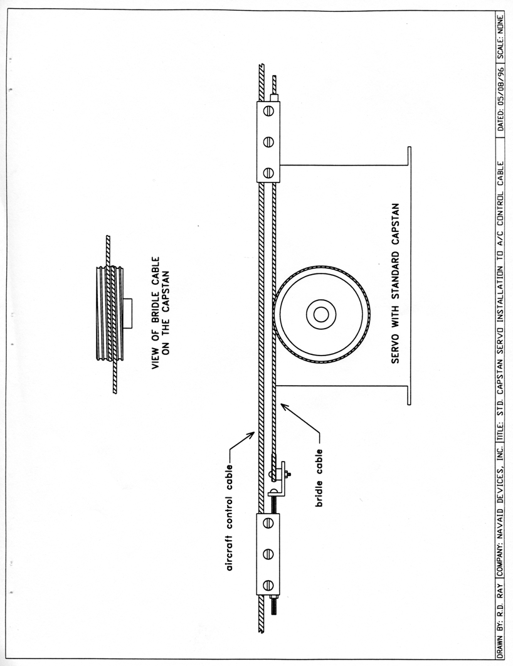

APPENDIX B

GYRO NULL ADJUSTMENT
If you accidentally turned the GYRO NULL trimpot, it will have to be adjusted. You will need a battery operated digital voltmeter. Do not use an AC powered meter unless it has the ability to measure a floating differential voltage.
Adjusting the GYRO NULL trimpot is easy; you just turn the trimpot until you voltmeter reads zero. There are two precautions:
1) You have to insure that the AP-1 is held stationary during the procedure since the slightest movement will affect the voltmeter reading.
2) The cover must be on the AP-1 because the gyro is sensitive to light.
Set your voltmeter to its most sensitive DC scale. Put the AP-l's MODE SWITCH in the center position. Put either voltmeter lead on pin 11 of the AP-l's rear connector (see Fig. 3 on page 7). The other lead goes on pin 10.
Apply power to the autopilot and adjust the GYRO NULL trimpot until the meter seems to average a zero reading. Even with the AP-1 held rock steady, it is normal for the reading to bounce around several tens of millivolts, so don't expect to get a perfect reading of zero, especially if you have a very sensitive meter.
If you cannot obtain a zero reading, there may be a problem with the autopilot. Call for assistance.

APPENDIX C
SMART COUPLER II
INSTALLATION
When installing the mode switch in the instrument panel, orient it so that the two-color LED is on top, and the word "HEADING" is on the right side.
Wire the NMEA 0183 output of your GPS receiver to pin 8 on the AP-1 main connector. Plug the telephone-type cable into the appropriate jacks in the back of the AP-1 and the mode switch.
INSTALLATION CHECK
After the installation is completed, you can quickly check if the Coupler is receiving and decoding information from the GPS receiver.
- Turn on the GPS receiver and put in a course from the present position to a nearby waypoint.
- Enable the serial output port from the GPS receiver to the AP-1.
- Apply power to the AP-1. The LED will alternately flash green and yellow several times.
- Try to select course or heading mode before the GPS receiver has acquired its minimum number of satellites. Do this by holding the switch to the left or right for ½ second. The LED will rapidly flash alternately green and yellow, and then go off. There should be 0±1 millivolts difference between pins 3 and 6 on the AP-1 connector. If you enable the AP-1 in tracking mode, you should be able to center the ailerons with the trim knob.
- Once the GPS receiver has acquired its satellites, press the Coupler mode switch to the left for ½ second. This selects Course mode, where the Coupler passes CDI information from the GPS receiver to the AP-1. The LED will glow green. There should still be less than 1 mV difference between pins 3 and 6.
- Now enter a course such that your present position is at least 1.25 NM off course.
- Again hold the switch to the left for ½ second to select Course mode. The LED will again glow green if the receiver is ready. There should be 150±10 mV difference between pins 3 and 6. The ailerons should be at full deflection.
- Turn off the GPS receiver but leave the power applied to the AP-1.
- After approximately 30 seconds, the Coupler LED will go off. The ailerons should go back to center.
- This completes the installation check.
AP-1 OPERATION WITH SMART COUPLER
Make sure that your GPS receiver is NOT, repeat NOT, in BATTERY SAVER Mode.
Course Mode
Put a course into the GPS receiver.
Enable the NMEA 183 output from the receiver.
Fly the aircraft to place it on course and on the correct heading. Enable the AP-1 in wing-leveler mode, and use the trim knob to ensure straight-and-level flight.
Move the mode switch to "COURSE" (to the left) and hold for ½ second. Note that the green LED comes on. If the LED blinks rapidly several times, then goes off, it means that the Smart Coupler is not receiving valid information from the GPS receiver.
Once the green LED is on and steady, then switch the AP-1 to tracking mode. Relax!
Heading Mode
Make sure that your GPS receiver is receiving and decoding course information, and that the NMEA output is enabled.
Fly the aircraft on heading for about 30 seconds to allow the GPS receiver to calculate your ground track. Use the AP-1 in wing-leveler mode and the trim knob as above.
Move the mode switch to "HEADING" (right) for ½ second. Note that the yellow LED comes on. If the LED blinks rapidly several times, then goes off, it means that the Smart Coupler is not receiving valid information from the GPS receiver.
Enable the AP-1 in tracking mode when the yellow LED is on and steady.
Minor heading changes can be made by pushing the mode switch left or right momentarily. The target heading will skew about 1 degree for every push.
To set the course width:
- Hold the Course/Heading switch either to the left or right when you turn on the autopilot. You must keep the switch engaged until the LEDs stop their normal turn-on flashing sequence.
- There is no indication that you have entered set mode.
- The coupler is factory-set to a course width of 1.25NM. Push the switch to the Heading position to increase course width by a factor of two. Push the switch to the Course position to decrease course width by a factor of two. After each push the course (green) or heading (yellow) LED will blink to indicate what gain is selected. You must wait until the course and heading LEDs are no longer blinking before selecting another gain setting. See the table below.
- When you are satisfied with the gain, turn the Coupler off to get out of Set Mode.

Course Width | Number of blinks
1.25NM | 1
2.5NM | 2
5NM | 3
10NM | 4

ADDENDUM
- Electrical transients during start-up may damage the integrated circuits in the autopilot. Therefore please provide a means for applying electrical power only after the engine is started. Attach the positive (B+) power lead from the AP-1 to your avionics master, a separate switch and fuse, or a breaker / switch.
- In some servo installations the sheet metal screws that normally fasten the lid through the side of the servo are inaccessible. If it is more convenient, just attach the lid using two of these same screws through appropriate holes in the top of the lid.

